**UNIX BASIC COMMANDS - PART 2**

Processes :

ps : list all processes

top : Monitor processes

kill : terminate processes



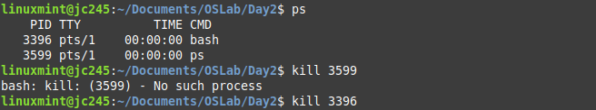

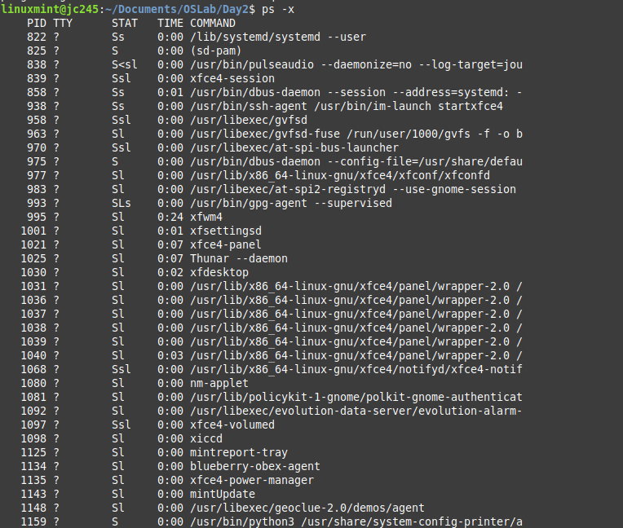

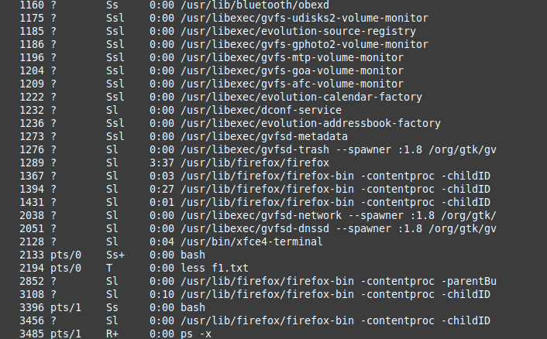

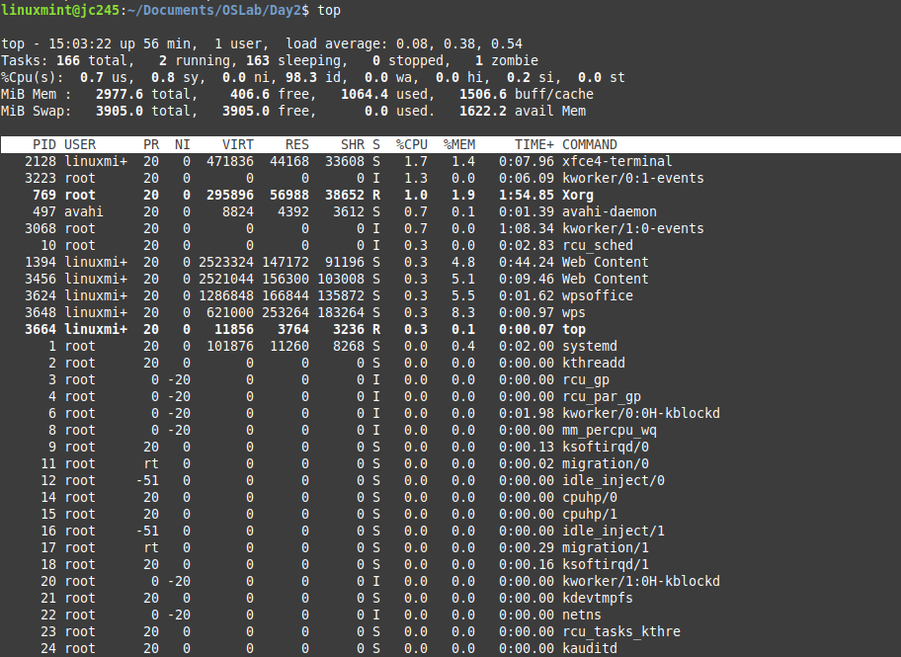

Hosts :

uname : Print system information

ifconfig : Set/ display network information

ping : Check if host is reachable

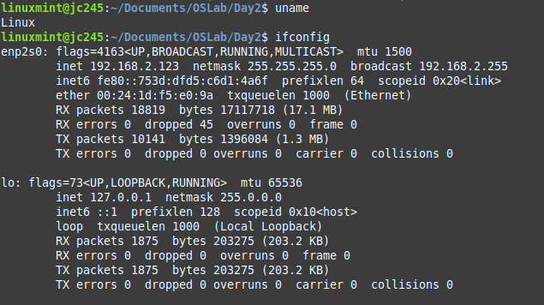

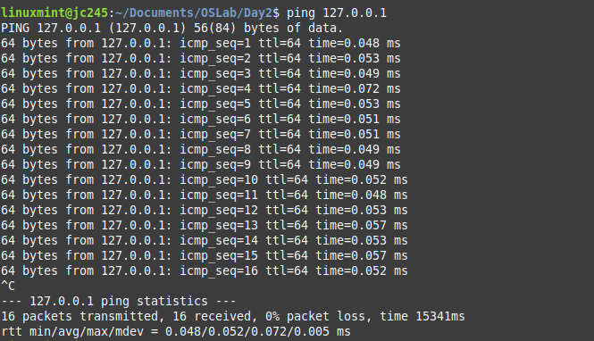

chmod : Change file protections

